Contacts Module

Table of Contents

1. View Contact (Company) 2

# View Contact (Company)

**Functional Description**

View Contact allows the User to view an existing Contact’s information including: contact info; level of engagement; next action; associated contacts; a history of actions and updates; and associated files.

**Fields**

|  |  |  |  |
| --- | --- | --- | --- |
| Name | Type | Additional Information | Validation |
| **Contact Summary** | | | |
| Employees | Link | See image in Notes section  Display as ‘[# of employees] People’  If # = 0, then do not display  If # = 1, then link to Contact record for the Contact  If # > 1, then link to Contact List filtered to display those Contacts |  |
| **Opportunity Summary (Right Sidebar)**  **NOTE: If Opportunities is configured where Customers are primarily Companies** | | | |
| Number of Won Opportunities | Link | Count the number of Opportunities where Stage = Won  Link to Search results containing a list of Opportunities Won for this Contact |  |
| Value of Won Opportunities | Text | Sum the value of Opportunities where Stage = Won  Link to Search results containing a list of Opportunities Won for this Contact |  |
| Number of Potential Opportunities | Link | Count the number of Opportunities where Stage = Won  Link to Search results containing a list of Opportunities Won for this Contact |  |
| Value of Potential Opportunities | Text | Sum the value of Opportunities where Stage = Won  Link to Search results containing a list of Opportunities Won for this Contact |  |
| **Opportunity (Right Sidebar)**  **NOTE: If Opportunities is configured where Customers are primarily People** | | | |
| Opportunity Name | Link | Display 3-5 Opportunities (the number depends upon available space and/or what works well to balance the UI)  Order by Expected Close Date from newest to oldest  Link to Opportunity record in Opportunity Module |  |
| Value | Text | Display as currency without decimals |  |
| Stage | Text | Display as: In [Stage] stage |  |
| Expected Closing Date | Text | Display as: Expected to close [Expected Close Date] |  |

**Actions or Controls**

No changes

**Navigation Options**

No changes

**Exceptions**

None

**Notes and Issues**

1. Location of Employees

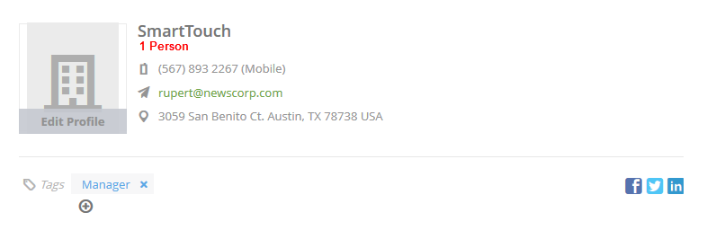

1. Opportunity in Sidebar

